Computer virus
❖ Computer Virus History: 2
❖ Common Signs of Computer Viruses: 2
➢ Speed of System 2
➢ Pop-up Windows 3
➢ Programs Self-executing 3
➢ Accounts Being Logged Out 3
➢ Crashing of the Device 3
➢ Mass Emails Being Sent from Your Email Account 3
➢ Changes to Your Homepage 3
❖ How Do Computer Viruses Attack and Spread? 3
❖ Common Types Of Computer Viruses: 3
➢ File-infecting Virus 4
➢ Macro Virus 4
➢ Browser Hijacker 4
➢ Web Scripting Virus 5
➢ Boot Sector Virus 5
➢ Polymorphic Virus 5
➢ Resident Virus 6
➢ Multipartite Virus 6
❖ How to Prevent Computer Viruses: 7
➢ Use Strong Passwords: 7
➢ Use a Firewall 7
➢ Install a Popup Blocker 7
➢ Beware of Email Phishing Scams 8
➢ Consider Additional Security Features 8
❖ References: 10

Computer virus
A computer virus is a type of malicious software, or malware, that spreads between computers and causes damage to data and software.
Computer viruses aim to disrupt systems, cause major operational issues, and result in data loss and leakage. A key thing to know about computer viruses is that they are designed to spread across programs and systems. Computer viruses typically attach to an executable host file, which results in their viral codes executing when a file is opened. The code then spreads from the document or software it is attached to via networks, drives, file-sharing programs, or infected email attachments.

Computer Virus History:
Traditional computer viruses were first widely seen in the late 1980s, and came about because of several factors.
- First factor:
The first factor was the spread of personal computers (PCs). Prior to the 1980s, home computers were nearly non-existent. Real computers were rare, and were locked away for use by "experts." During the '80s, real computers started to spread to businesses and homes because of the popularity of the IBM PC (released in 1982) and the Apple Macintosh (released in 1984). By the late 1980s, PCs were in businesses, homes and college campuses. ((NASDAQ: FTNT), 2022)
- Second factor:
The second factor was the use of computer bulletin boards. People could dial up a bulletin board with a modem and download programs of all types. Games were extremely popular, and so were simple word processors, spreadsheets and other productivity software. Bulletin boards led to the precursor of the virus known as the Trojan horse. A Trojan horse masquerades as a program with a cool-sounding name and description, enticing you to download it. When you run the program, however, it does something uncool, like erasing your hard drive. You think you're getting a neat game, but instead, you get a wiped-out system. Trojan horses only hit a small number of people because they're quickly discovered, and word of the danger spreads among users. ((NASDAQ: FTNT), 2022)
- Third factor:
The third factor that led to the creation of viruses was the floppy disk. In the 1980s, programs were small, and you could fit the entire operating system, a few programs and some documents onto a floppy disk or two. Many computers did not have hard disks, so when you turned on your machine it would load the operating system and everything else from the floppy disk. Virus authors took advantage of this to create the first self-replicating programs. ((NASDAQ: FTNT), 2022)
- Common Signs of Computer Viruses:
A computer virus will more than likely have an adverse effect on the device it resides on and maybe discoverable through common signs of performance loss, including: ((NASDAQ: FTNT), 2022)
- Speed of System
A computer system running slower than usual is one of the most common signs that the device has a virus. This includes the system itself running slowly, as well as applications and internet speed suffering. If a computer does not have powerful applications or programs installed and is running slowly, then it may be a sign it is infected with a virus. ((NASDAQ: FTNT), 2022)
- Pop-up Windows
Unwanted pop-up windows appearing on a computer or in a web browser are a telltale sign of a computer virus. Unwanted pop-ups are a sign of malware, viruses, or spyware affecting a device. ((NASDAQ: FTNT), 2022)
- Programs Self-executing
If computer programs unexpectedly close by themselves, then it is highly likely that the software has been infected with some form of virus or malware. Another indicator of a virus is when applications fail to load when selected from the Start menu or their desktop icon. ((NASDAQ: FTNT), 2022)
- Accounts Being Logged Out
Some viruses are designed to affect specific applications, which will eit (Florida Nerds, 2022)her cause them to crash or force the user to automatically log out of the service. ((NASDAQ: FTNT), 2022)
- Crashing of the Device
System crashes and the computer itself unexpectedly closing down are common indicators of a virus. Computer viruses cause computers to act in a variety of strange ways, which may include opening files by themselves, displaying unusual error messages, or clicking keys at random. ((NASDAQ: FTNT), 2022)
- Mass Emails Being Sent from Your Email Account
Computer viruses are commonly spread via email. Hackers can use other people's email accounts to spread malware and carry out wider cyberattacks. Therefore, if an email account has sent emails in the outbox that a user did not send, then this could be a sign of a computer virus. ((NASDAQ: FTNT), 2022)
- Changes to Your Homepage
Any unexpected changes to a computer—such as your system’s homepage being amended or any browser settings being updated—are signs that a computer virus may be present on the device. ((NASDAQ: FTNT), 2022)
- How Do Computer Viruses Attack and Spread?
In the early days of computers, viruses were spread between devices using floppy disks. Nowadays, viruses can still be spread via hard disks and Universal Serial Bus (USB) devices, but they are more likely to be passed between devices through the internet.
Computer viruses can be spread via email, with some even capable of hijacking email software to spread themselves. Others may attach to legitimate software, within software packs, or infect code, and other viruses can be downloaded from compromised application stores and infected code repositories. A key feature of any computer virus is it requires a victim to execute its code or payload, which means the host application should be running.

Common Types Of Computer Viruses:
Cybercriminals are getting better and better at stealing our confidential data and viruses that are being created are evolving rapidly. There are millions of viruses around the world, but here are some common types you should be aware of:

File-infecting Virus
A virus that attached itself to an executable program. It is also called a parasitic virus which typically infects files with .exe or .com extensions. Some file infectors can overwrite host files and others can damage your hard drive’s formatting. (Florida Nerds, 2022)
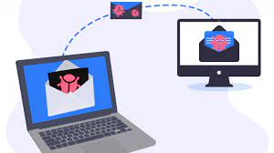
Figure 1--file-infecting virus

Macro Virus
This type of virus is commonly found in programs such as Microsoft Word or Excel. These viruses are usually stored as part of a document and can spread when the files are transmitted to other computers, often through email attachments (Florida Nerds, 2022)
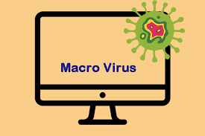
Figure 2--Macro Virus

Browser Hijacker
This virus targets and alters your browser setting. It is often called a browser redirect virus because it redirects your browser to other malicious websites that you don’t have any intention of visiting. This virus can pose other threats such as changing the default home page of your browser. (Florida Nerds, 2022)

Figure 3__Browser Hijacker

Web Scripting Virus
A very sneaky virus that targets popular websites. What this virus does is overwrite code on a website and insert links that can install malicious software on your device. Web scripting viruses can steal your cookies and use the information to post on your behalf on the infected website. (Florida Nerds, 2022)
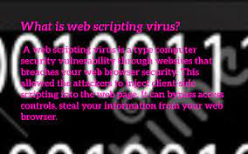
Figure 4---Web Scripting Virus

Boot Sector Virus
These viruses are once common back when computers are booted from floppy disks. Today, these viruses are found distributed in forms of physical media such as external hard drives or USB. If the computer is infected with a boot sector virus, it automatically loads into the memory enabling control of your computer. (Florida Nerds, 2022)
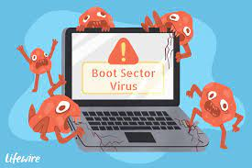
Figure 5___Boot Sector Virus

Polymorphic Virus
This virus has the capability to evade anti-virus programs since it can change codes every time an infected file is performed. (Florida Nerds, 2022)
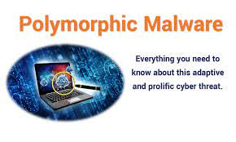
Figure 6__Polymorphic Virus

Resident Virus
A resident virus stores itself on your computer’s memory which allows it to infect files on your computer. This virus can interfere with your operating system leading to file and program corruption. (Florida Nerds, 2022)
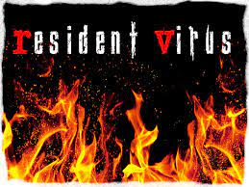
Figure 7__Resident Virus

Multipartite Virus
A type of virus that is very infectious and can easily spread on your computer system. It can infect multiple parts of a system including memory, files, and boot sector which makes it difficult to contain. (Florida Nerds, 2022)
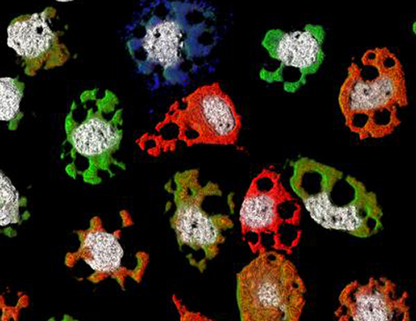
Figure 8__Multipartite Virus

How to Prevent Computer Viruses:
to protect your computer from cyber-attacks. Read on to learn more—your personal and business security depends on it.

Use Strong Passwords:
The most commonly used passwords in the cyber world are also the worst. As of 2018, the top 3 passwords in use were:
- 123456
- password
- 123456789
And people wonder why we have security breaches everywhere?
Keep your data safe by creating unique, complex passwords. The best passwords include a mix of numbers, letters, and symbols and are at least 8 characters long.
While we’re on the topic, avoid using the same username and password combination across multiple sites. If a hacker can access just one site, you’ve left the door wide open to the rest of your data
Another basic step to take is to make sure you have the latest versions of all software installed on your devices.
Why is this so important? Because software updates include features designed to withstand the latest security threats. Microsoft, Oracle, and other makers regularly update their software to eliminate “bugs” that hackers could exploit.
If you’re operating a system from 3 years ago, it’s defenseless against any viruses or malware developed in the interim. Make it a habit to install all new software updates as soon as they become available
Next up on our list of how to prevent computer viruses is—no surprise here—antivirus software.
Antivirus software acts as a “vaccine” against virtual viruses. It can identify and eliminate the threat before you were even aware of it.
Microsoft Security Essentials and Avast are both free antivirus programs you can install. There’s also a host of paid options, although experts debate whether the extra cost is really worth it. (uniserveit, 2008)

Use a Firewall
Using antivirus programs doesn’t automatically mean you have a firewall.
Macs and PCs both come with pre-installed firewall software. Make sure it’s enabled to provide an extra layer of protection from viruses and malware. (uniserveit, 2008)

Install a Popup Blocker
Many attacks happen through browsers, as you’re going about your daily online routine. Hackers can gain access to your computer from one innocent click on the wrong ad or link.
An ad or popup blocker is essential to protecting your computer’s data. It will prevent any unwanted pages from opening automatically.
Never click on, open, or download anything unless you know exactly who it’s from. This is especially important with emails, which is our next topic. (Florida Nerds, 2022)

Beware of Email Phishing Scams
32% of reported security breaches begin with a phishing scam.
These appear in email form under the guise of a legitimate company. The goal is to get you to either enter personal information or click on an infected link that allows access to your computer.
Any legitimate company will have its own domain name for emails. If an email address claims to be from Paypal or Netflix but ends with @gmail.com, it’s a scam.
Other signs include misspellings, poor grammar, and suspicious attachments, buttons, or links. A legitimate company will never invite you via email to log in and provide personal or billing
Most cyber-attacks happen through an innocent action by an uninformed person.
This could be a member of your family, a child, or an employee who isn’t aware of smart internet practices.
If you have any doubts about anyone who uses your computer, take a few moments to teach them the basics. Review a few points from this post, such as not opening emails or clicking on links from unknown sources.
A few moments of education could mean the difference between cyberattack success or failure
Here are a few things to watch for:
- Repeated error messages
- Unexpected shutdowns
- Computer suddenly slows down
- Takes too long to shut down or restart
- New toolbars you didn’t install
- Changes to your homepage
- Rapidly draining battery
Any of these signs could mean your computer is infected. If you see more than one of these signs, you almost surely have a virus.
Make sure all your software is updated and then perform a scan. You can also search online forums for users who have similar issues and see how they were able to solve them. (uniserveit, 2008)

Consider Additional Security Features
At the very least, you should perform weekly or even daily backups of all important data. Store it securely in the cloud or on a separate hard drive.
That way, if you do accidentally get a virus, your vital information won’t be lost or compromised. (uniserveit, 2008)

- Flowchart/Process Flow Diagram:
Action
Process 2

Process 3
Process 1

End
Start
Decision

- Table:
Subject name | Mid term | Quiz #01 | Quiz #02 | Quiz #03 | Final term | Assignment #01 | Assignment #02 | Assignment #03 | Total
English | 18 | 2 | 4 | 4 | 30 | 4 | 3 | 3 | 68
physics | 13 | 2 | 3 | 2 | 25 | 3 | 2 | 3 | 53
IICT | 18 | 3 | 5 | 3 | 35 | 2 | 3 | 4 | 73
PF | 15 | 3 | 2 | 2 | 20 | 5 | 4 | 5 | 56
Islamyat | 20 | 3 | 3 | 1 | 29 | 4 | 5 | 3 | 63
Accounting | 21 | 5 | 4 | 2 | 38 | 3 | 4 | 2 | 80
total |  |  |  |  |  |  |  |  | 393
Table 1 result of bsse
- Table of Figures:
Figure 1--file-infecting virus 4
Figure 2--Macro Virus 4
Figure 3__Browser Hijacker 5
Figure 4---Web Scripting Virus 5
Figure 5___Boot Sector Virus 6
Figure 6__Polymorphic Virus 6
Figure 7__Resident Virus 6
Figure 8__Multipartite Virus 7

References:

(NASDAQ: FTNT). (2022, 05 21). cyberglossary. Retrieved from fortinet.com: https://www.fortinet.com/corporate/about-us/about-us

Florida Nerds. (2022, 05 21). how-to-prevent-computer-viruses-9-tips-to-keep-your-pc-safe. Retrieved from Florida Nerds: https://flnerds.com/blog/how-to-prevent-computer-viruses-9-tips-to-keep-your-pc-safe/

uniserveit. (2008, 02 11). what-are-the-different-types-of-computer-viruses. Retrieved from uniserveit.com: https://uniserveit.com/leading-it-service-provider

